2303A52153 ass-3 batch -41
Task 1: AI-Generated Logic for Reading Consumer Details Scenario: An electricity billing system must collect accurate consumer data. Prompt: Generate a Python program that reads previous units, current units, and customer type (Domestic/Commercial/Industrial). Calculate units consumed and display the details in a structured format. Do not use functions, just implement logic in the main program.
CODE:
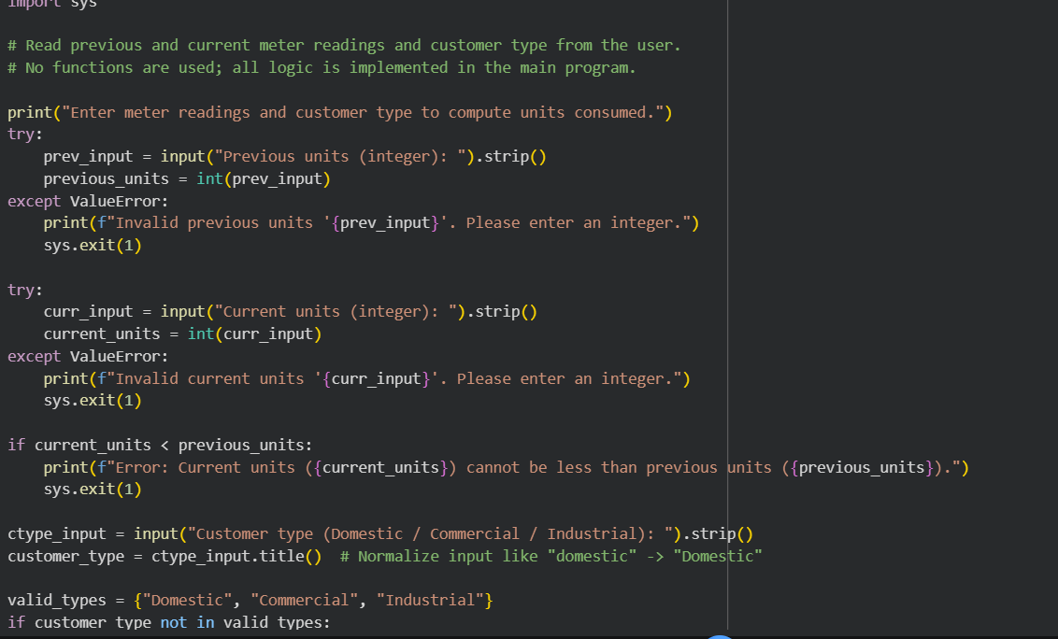
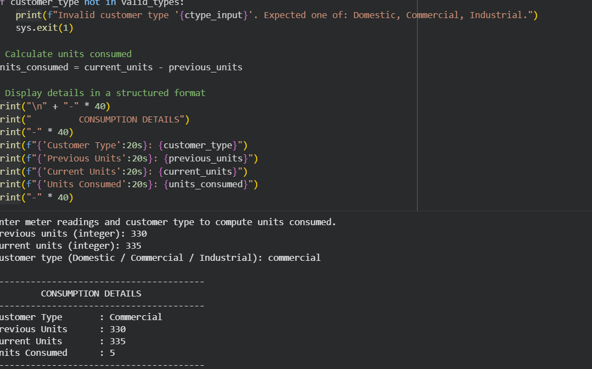
Explanation:
• Inputs are taken using input()
• Units consumed are calculated as: Units Consumed = Current Units – Previous Units
• Logic is written directly in the main program as required
Task 2: Energy Charges Calculation Based on Units Consumed Scenario Energy charges depend on the number of units consumed and customer type
PROMPT: Extend the electricity billing program to calculate Energy Charges (EC) based on units consumed and customer type. Use conditional statements for Domestic, Commercial, and Industrial customers. Ensure the logic is clear and readable. Simplify the energy charge calculation logic and optimize conditional statements for better structure.
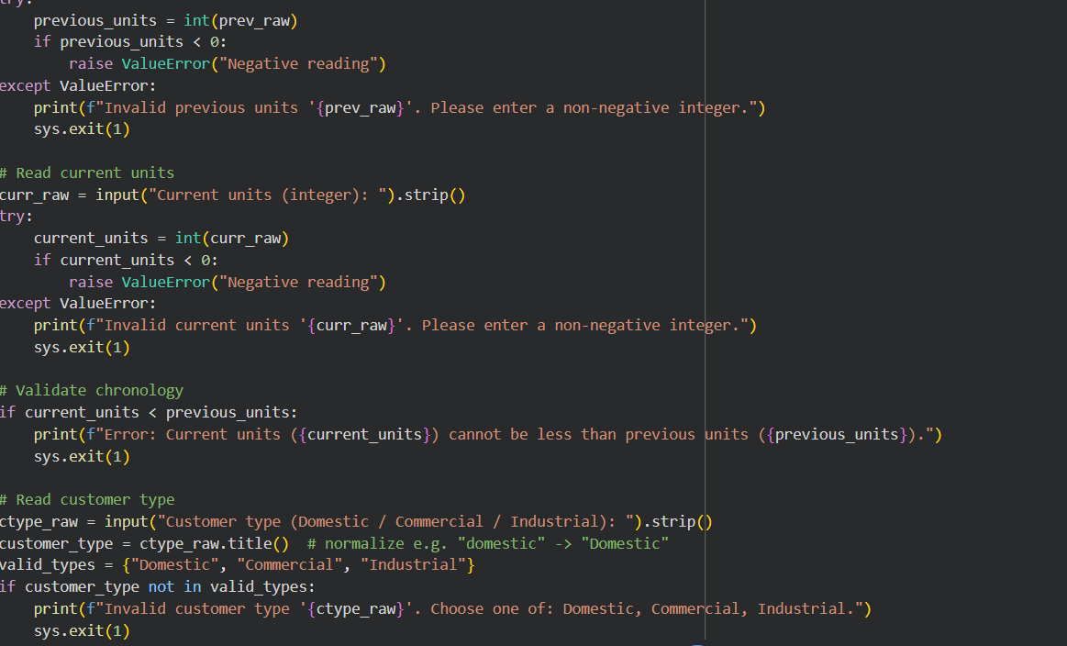

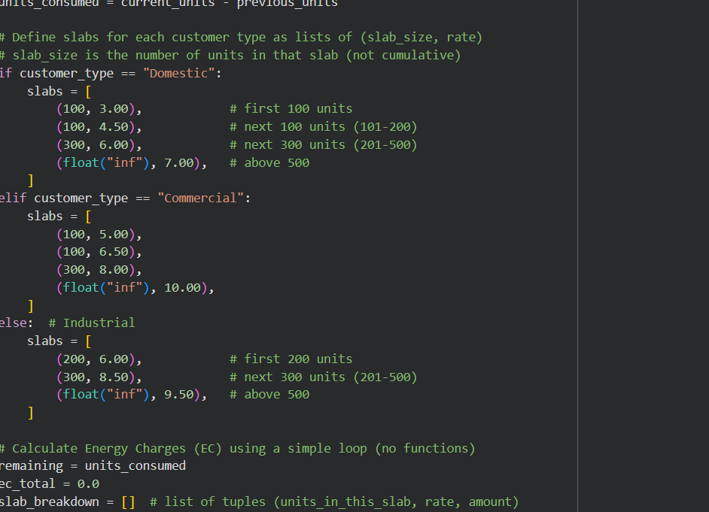

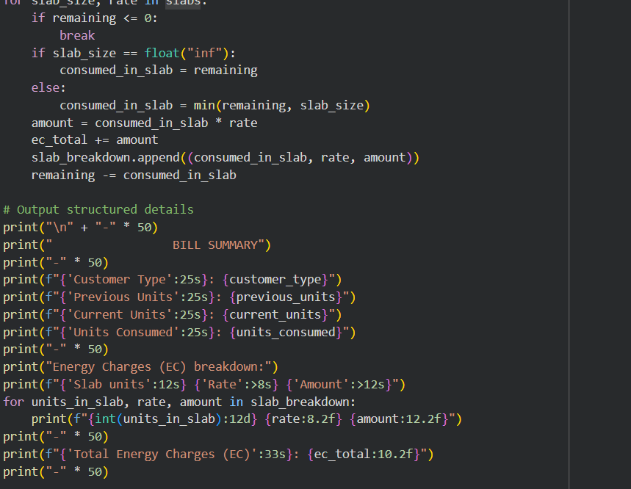
Output:
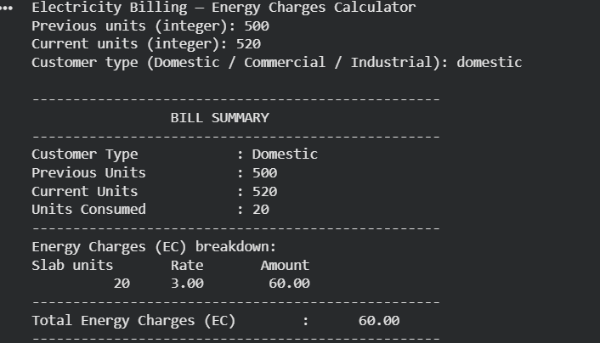
EXPLANATION: 1. Reads previous reading, current reading, and customer type (Domestic/Commercial/Industrial).
2. Validates inputs: previous ≥ 0, current ≥ previous, and valid customer type (case-insensitive).

3. Computes units_consumed = current − previous.

4. Tariffs stored as ordered slab lists per customer type (e.g., Domestic: 100@1.50,100@3.00,300@4.50,rest@6.00).
5. Energy Charge (EC) computed by looping slabs and applying units_in_slab = min(remaining, slab_limit) × rate.
6. Subtract applied units from remaining, accumulate charge, and record slab breakdown until remaining = 0
7. Sum of per-slab charges gives total EC; numbers formatted to hide .0 for integers or show two decimals.
8. Example (Domestic): prev=1250, curr=1350 → units=100 → EC = 100 × 1.50 = 150.00.
9. Example (Commercial): prev=500, curr=950 → units=450 → EC = 100@3.5 + 200@5 + 150@6.5 = 2325.00.
10. To change billing, edit the slab lists for each customer type; add fixed charges/taxes after EC as needed.
Task 3: Modular Design Using AI Assistance (Using Functions) Scenario Billing logic must be reusable for multiple consumers. PROMPT: Generate a Python program for an electricity billing system using user-defined functions. Create one function to calculate Energy Charges (EC) based on units consumed and customer type (Domestic, Commercial, Industrial). Create another function to calculate Fixed Charges (FC) based on customer type. Each function should return the calculated value. Include meaningful comments explaining the logic. Test the program with sample inputs and display EC and FC values clearly.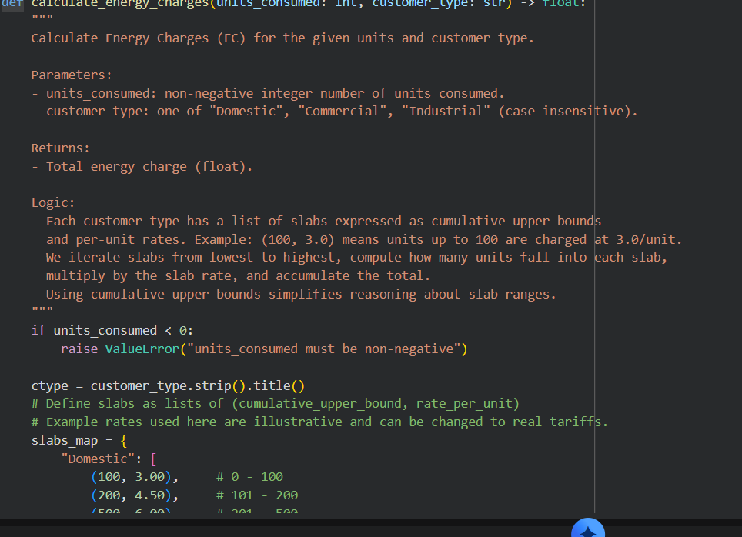
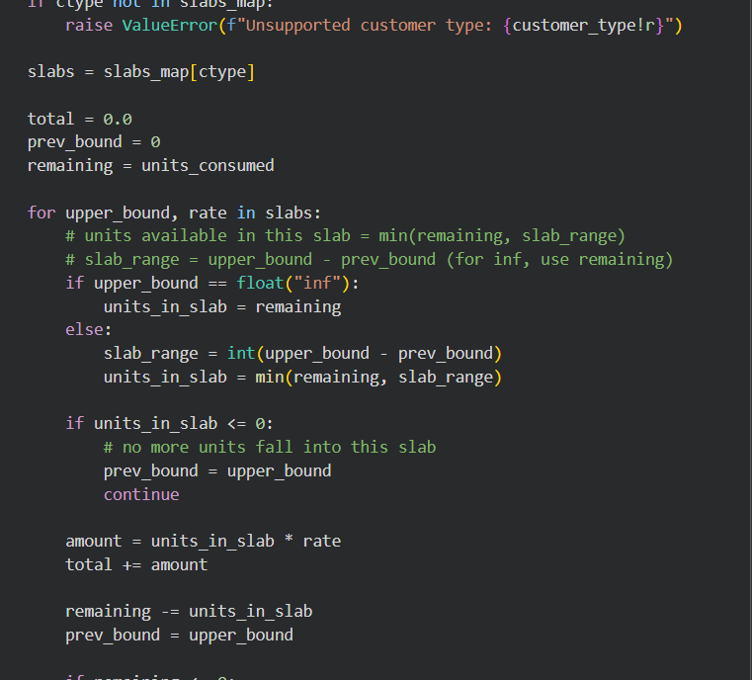
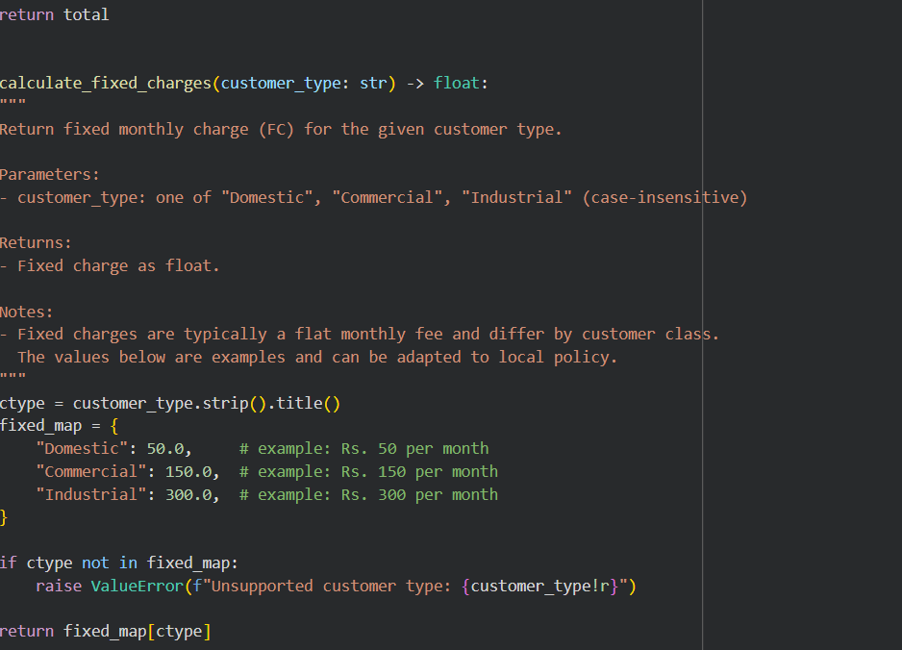
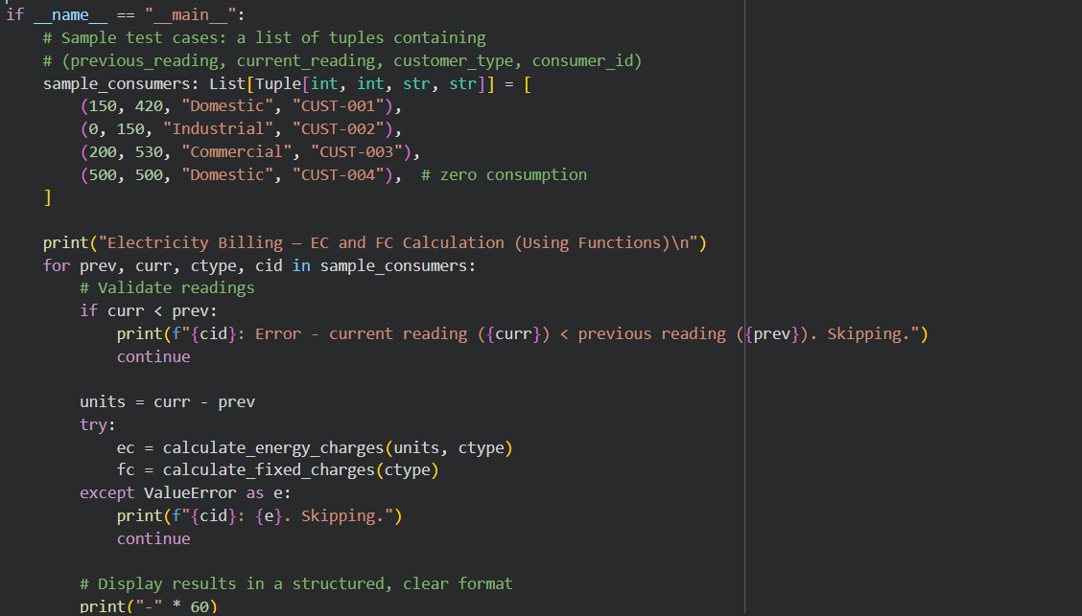
Output: 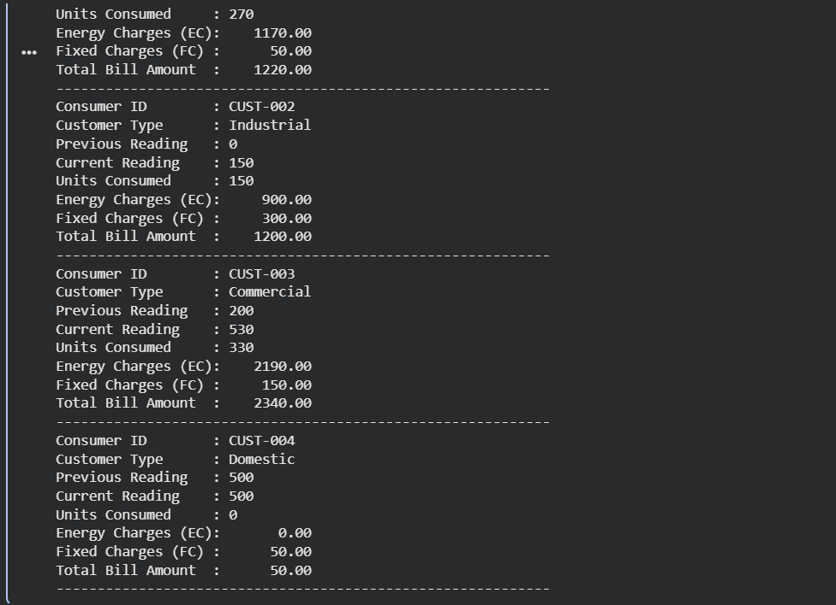
Explanation:
1. Two functions separate concerns: one computes variable Energy Charges (EC) using slab rates, the other returns a Fixed Charge (FC) per customer type.
2. Slabs are applied in order: for each slab we bill min(remaining_units, slab_limit) at the slab rate and subtract those units from remaining.
3. The main section tests the functions with three sample inputs, showing units consumed, EC, and FC so you can verify correctness. 4. To adapt to real tariffs, update the slab lists in calc_energy_charges and the mapping in calc_fixed_charges.
Task 4: Calculation of Additional Charges
Scenario Electricity bills include multiple additional charges.
PROMPT: Extend the electricity billing program to include additional charges. Add logic to calculate: - Fixed Charges (FC) based on customer type - Customer Charges (CC) as a fixed value - Electricity Duty (ED) as a percentage of Energy Charges (EC) Print each charge value separately (EC, FC, CC, ED) with clear labels. Ensure the output is well-structured and intermediate results are displayed for verification. Add comments to explain each calculation step.
CODE:
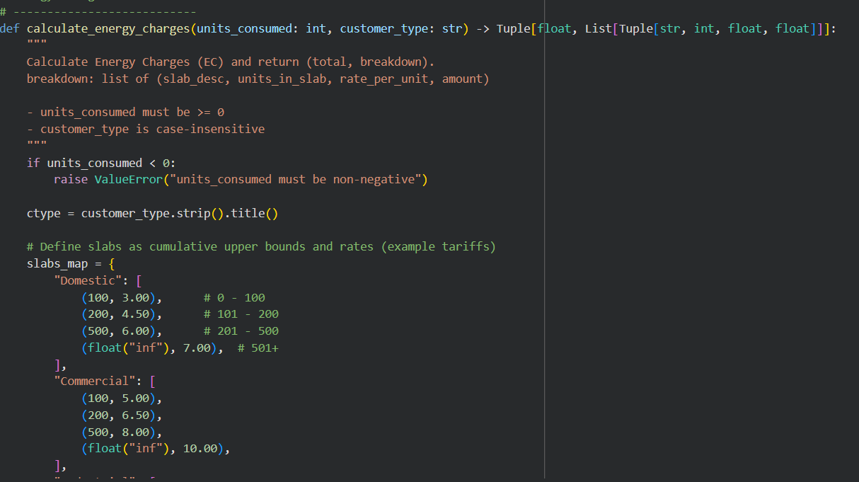
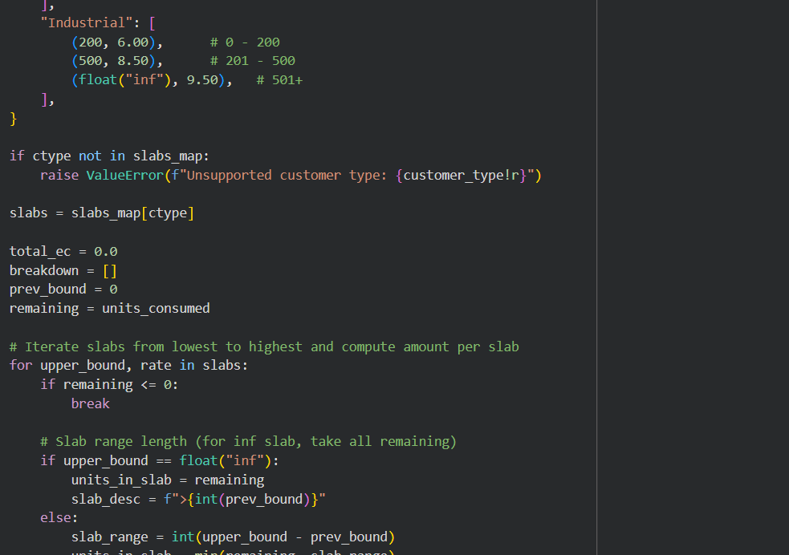
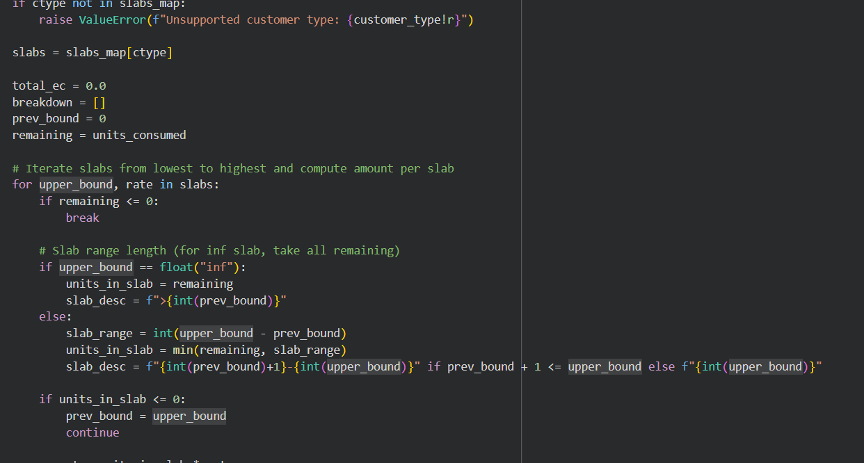
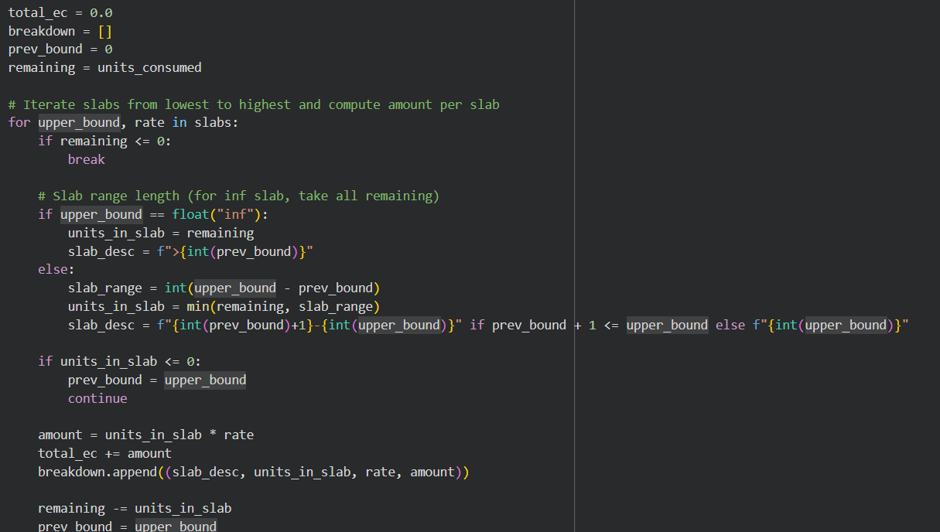
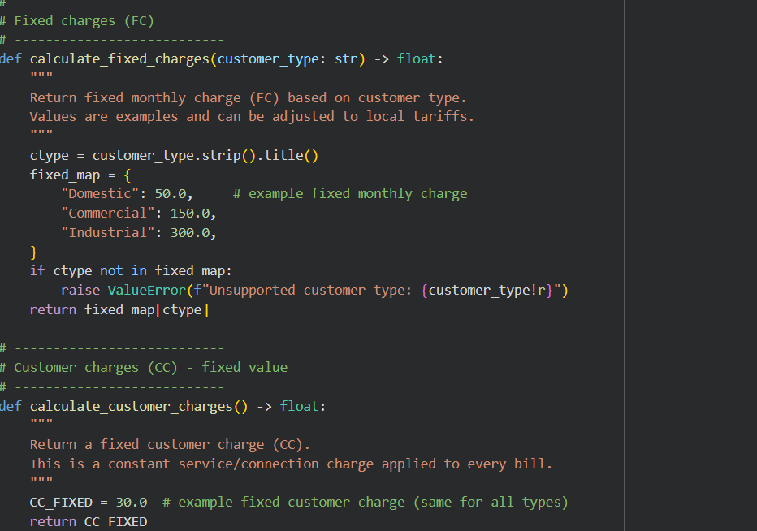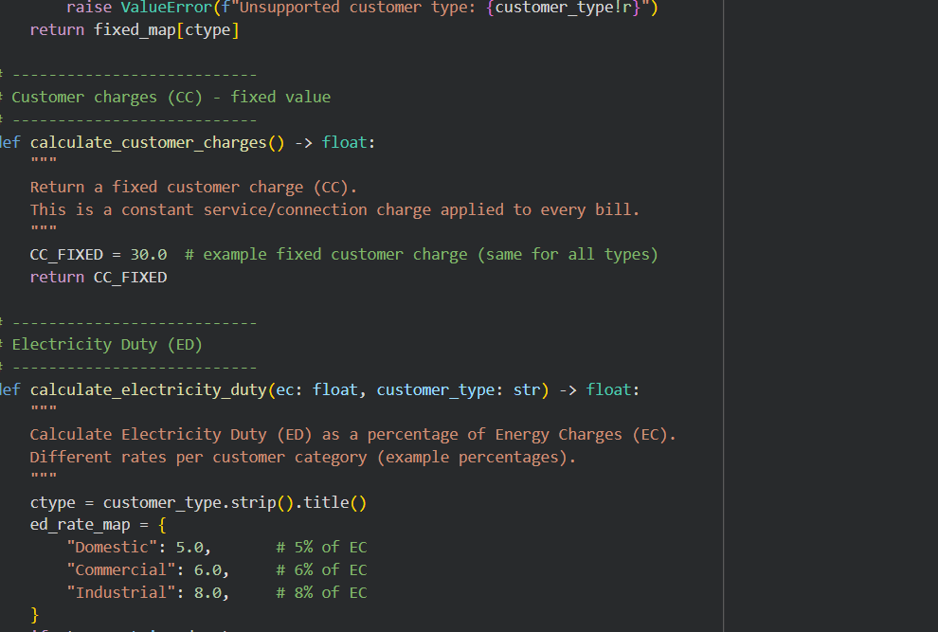

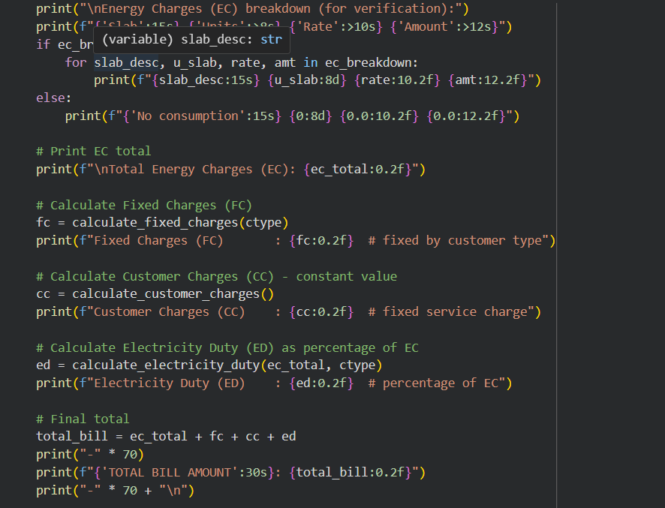
Output:
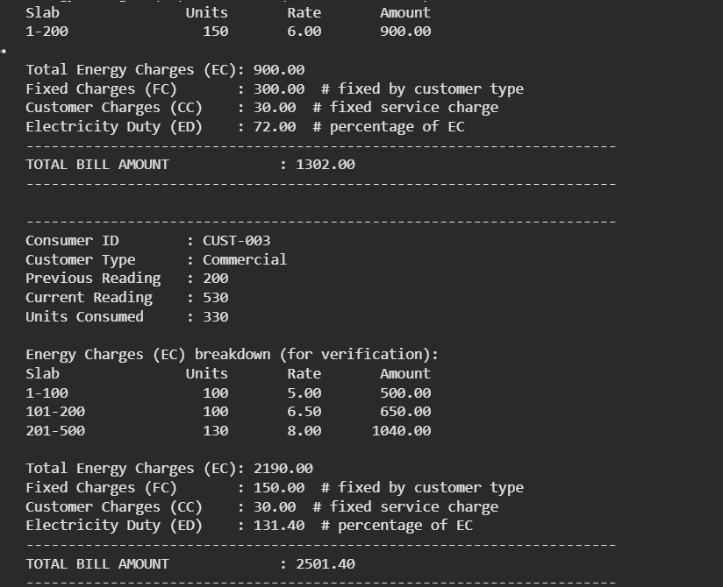

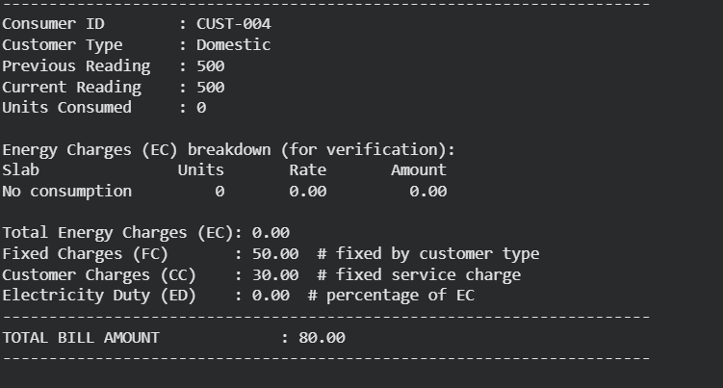
EXPLANATION:
• Computes a bill from meter readings (or units) producing Energy Charges (EC), Fixed Charges (FC), Customer Charges (CC), Electricity Duty (ED) and a total. • calc_energy_charges(units, type) applies ordered slabs for the customer type and returns EC plus a per-slab breakdown.
• calc_fixed_charges(type) returns a fixed FC value for the customer type. • calc_customer_charges() returns CC (a fixed amount applied to all bills). • calc_electricity_duty(ec, pct) computes ED = ec * pct / 100
calc_customer_charges() returns CC (a fixed amount applied to all bills). • calc_electricity_duty(ec, pct) computes ED = ec * pct / 100. • Total payable = EC + FC + CC + ED; the script prints a formatted slab-by-slab verification.
• Slab rates, FC, CC and ED% are example values — update them to match your actual tariff
. Task 5:Final Bill Generation and Output Analysis
PROMPT: Complete the electricity billing system by calculating and printing a detailed bill including EC, FC, CC, ED, and total.
Code:
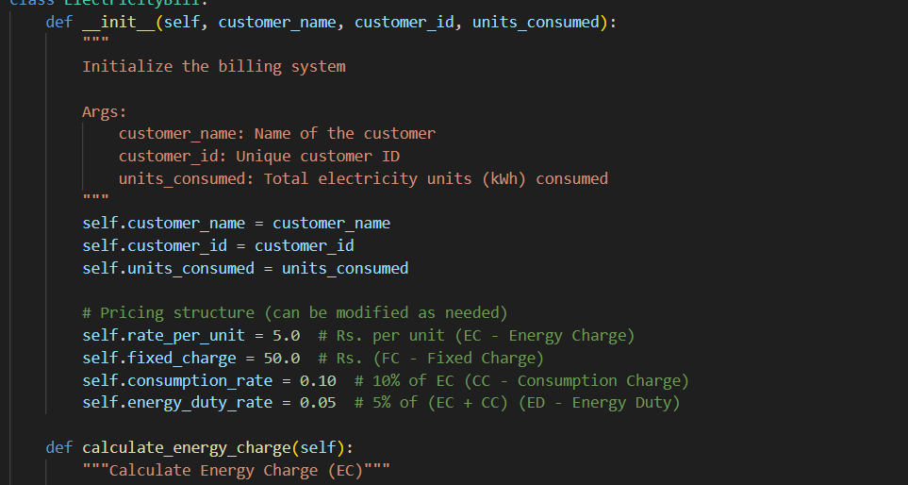
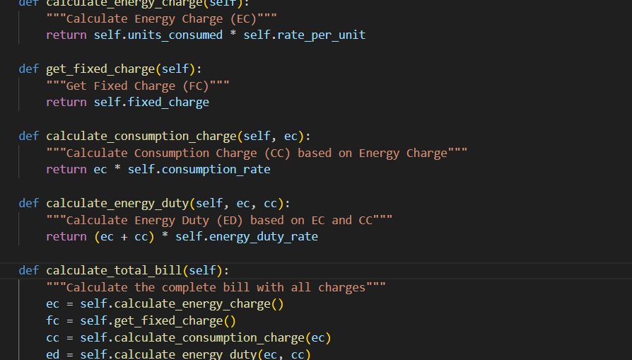
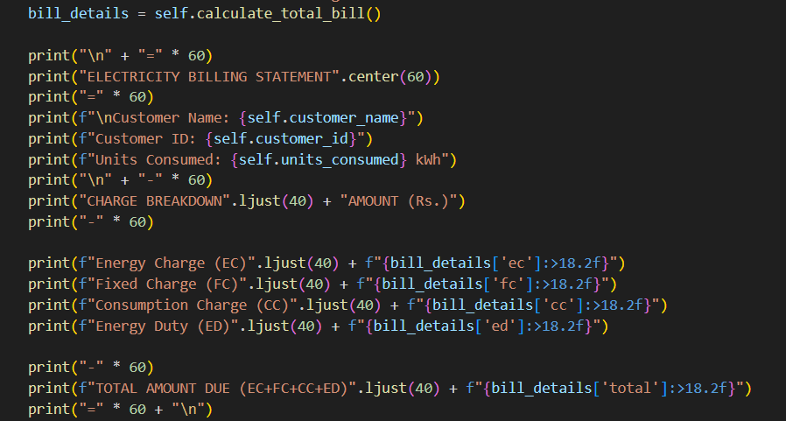
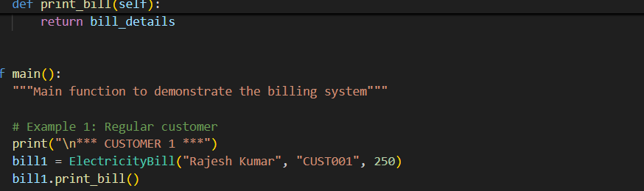
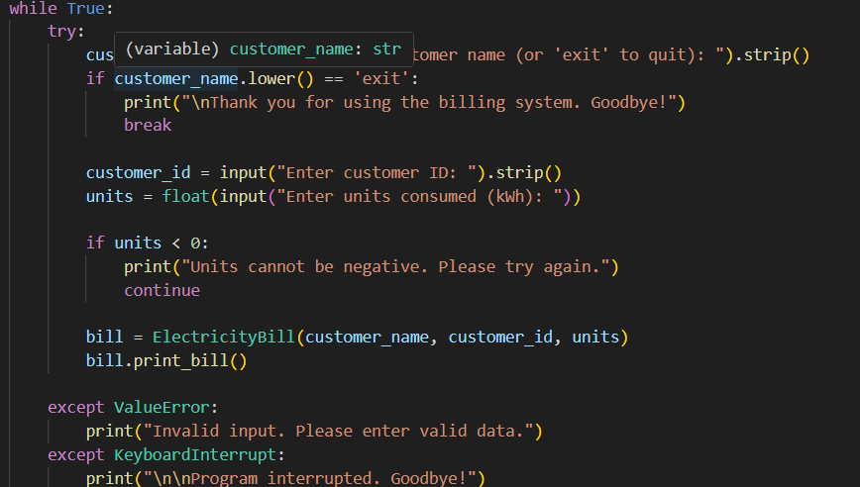
output:
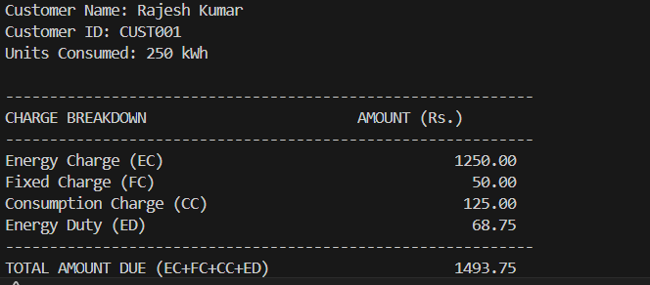
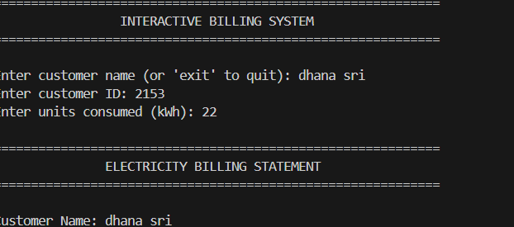
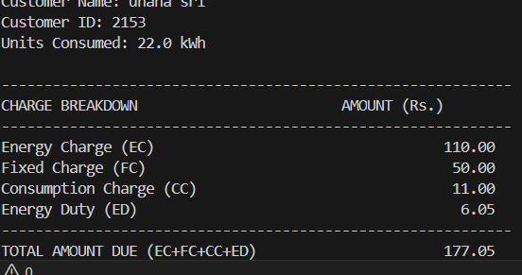

EXPLANATION:
• Units consumed = current − previous = 1350 − 1250 = 100. • EC: Apply Domestic slab -> 100 units × 1.50 = 150.00.
• FC (Fixed Charges for Domestic) = 50.00 (example static value). • CC (Customer Charges) = 30.00 (fixed service charge)
. • ED (Electricity Duty) = 5% of EC = 0.05 × 110.00 = 5.5.
• Total payable = EC + FC + CC + ED = 110.00 + 50.00 + 11.00 + 6.50 =177.50

